AI ASSISTED CODING:
LAB ASSIGNMENT 4.3:
NAME:VAISHNAVI VARDINENI
HT NO:2403A51431
BATCH:16
TASK 1:
Write a python program to check whether the year is leap year using functions.
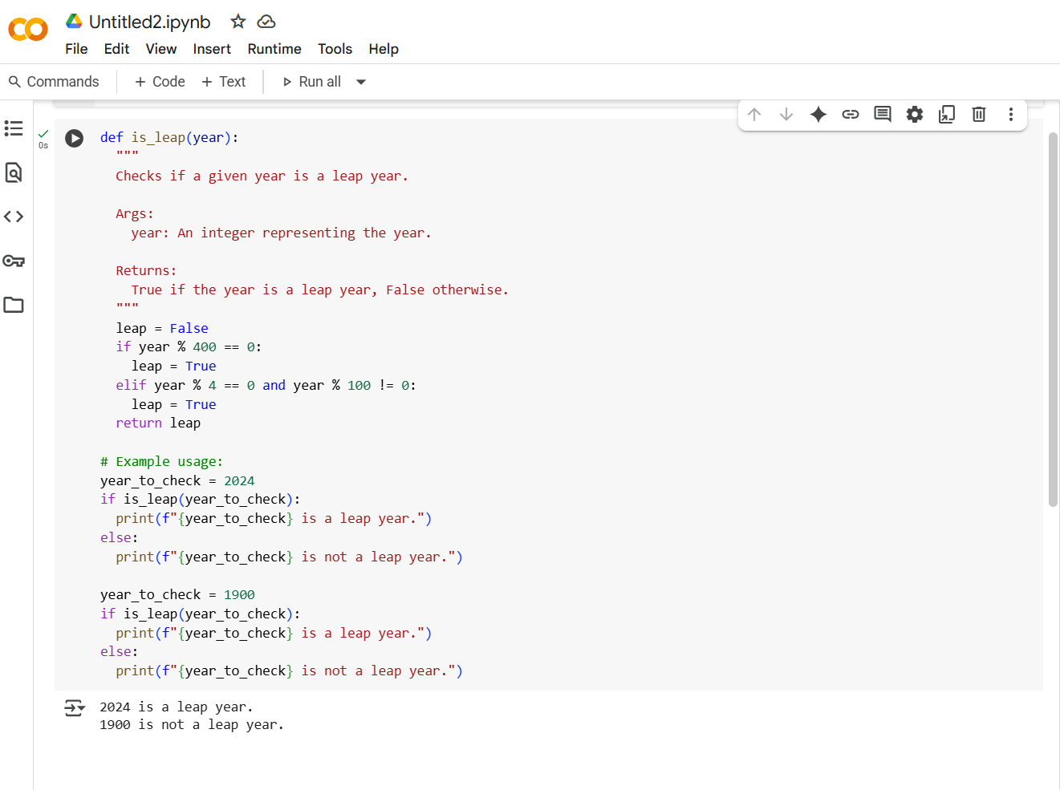

OUTPUT:
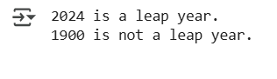

EXPLANATION:
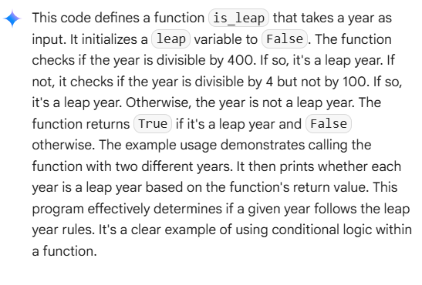
TASK 2:
Generate a python program using functions which coverts centimeters to inches using 1 inch = 2.54 centimeters. Give the result rounded to 2 decimal places.
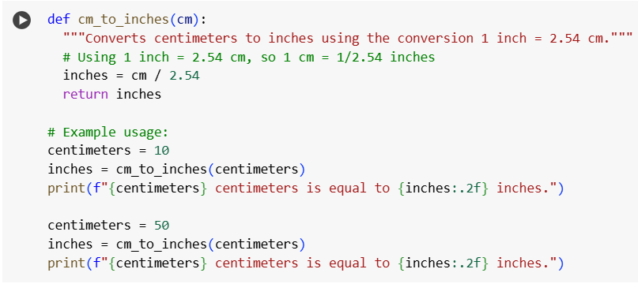

Output:
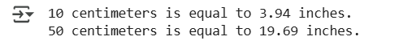
Explanation:
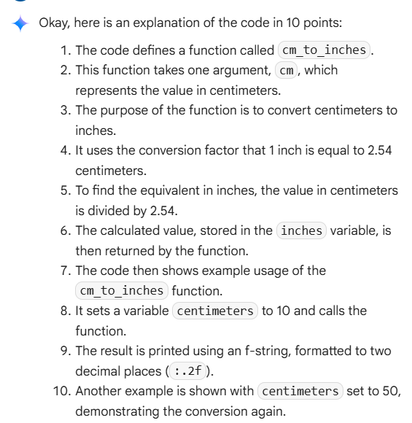

TASK 3:
Write python code that converts full names and format full names as last and first names. ex Vardineni Vaishnavi as Vaishnavi Vardineni ex2: Burgadda Akshitha as Akshitha Burgadda.
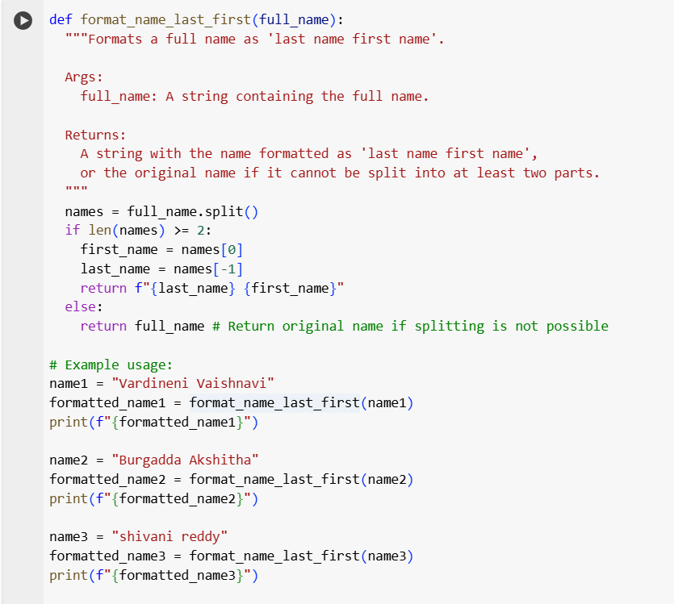

OUTPUT:

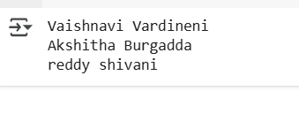
EXPLANATION:
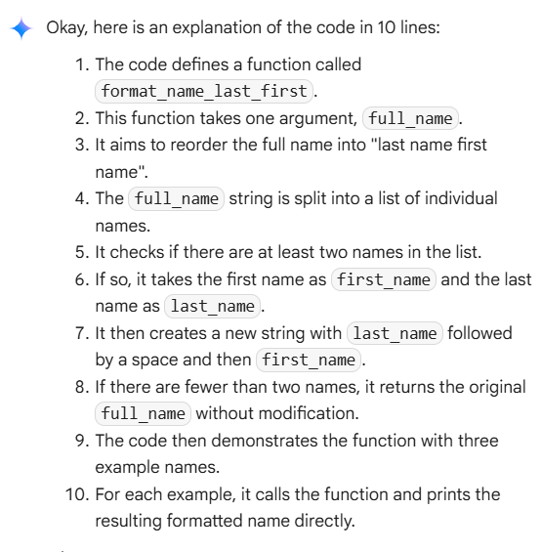
TASK 4:
Zero shot: Write a Python function count_vowels(text) that returns the number of vowels (a, e, i, o, u) in a given string.
One shot: Write a Python function that counts the number of vowels (a, e, i, o, u) in a string.
Examples:
Input 1: "hello" Output: 2
Input 2: "OpenAI" Output: 4
Now, write a Python function count_vowels(text) that follows the same pattern.
CODE:
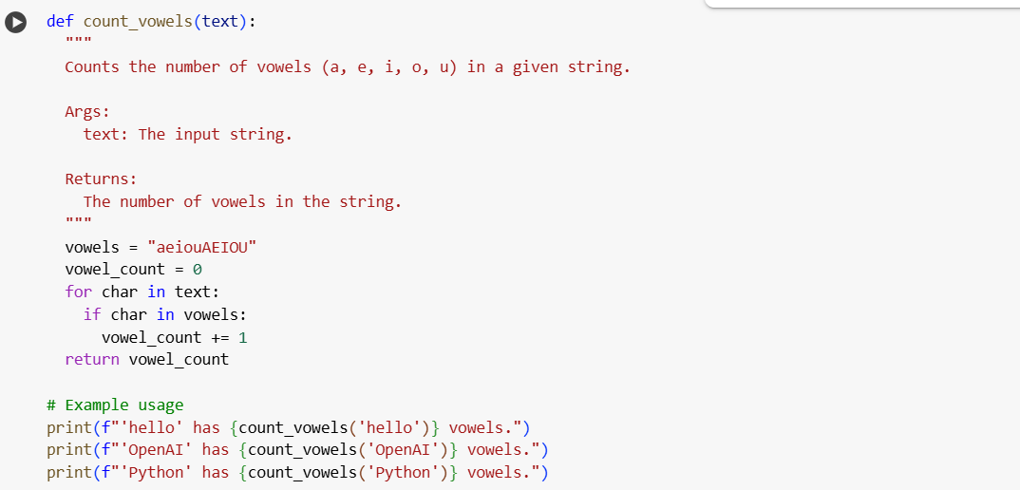
OUTPUT:
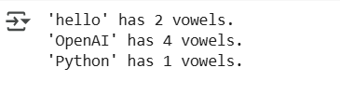
EXPLANATION:
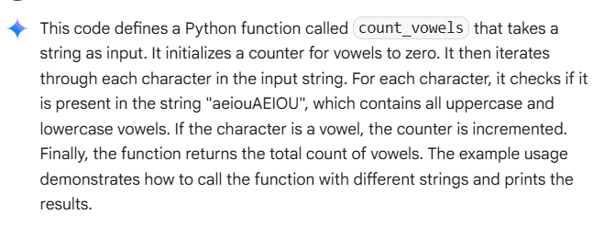

TASK5:
Generate a Python function that reads a .txt file and returns the number of lines. For example:
Input: sample.txt with 3 lines → Output: 3
Input: empty.txt → Output: 0
CODE:
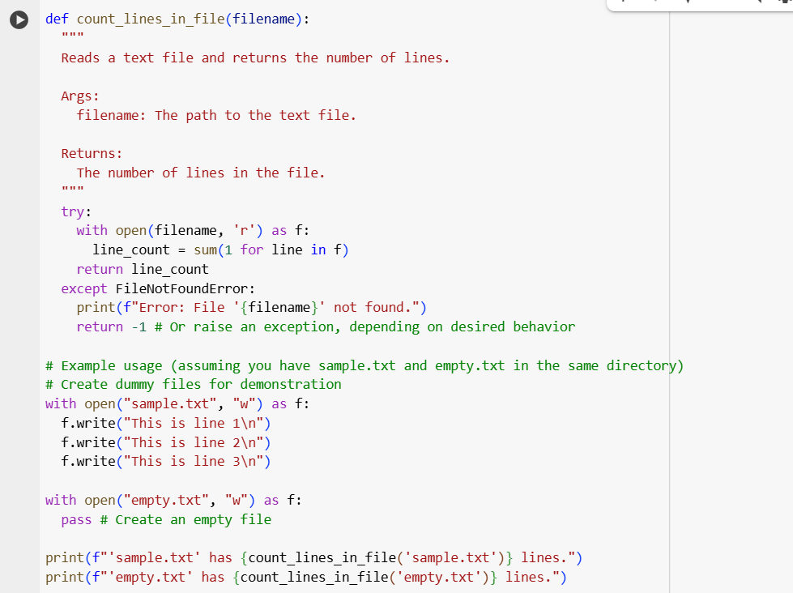
OUTPUT:



EXPLANATION:
